|  |
| --- |
|  |

Hardware Specification

This is not my leg

Saman Tehrani  |  Thesis Studio 2  |  2016

# Introduction

This document will cover all the hardware specifications from all of the iterations of my thesis project. The three sections below are:

1. Terminology
2. Hardware Components:
3. Diagrams:

# Terminology

I2C interface

I2C Master Slave

Serial Interface

UART Interface

Software Serial

Application Specific Sensor Nodes ( ASSN )

System in Package (SiP)

MEMS

Accelerometer

Magnetometer

Gyroscope

# Hardware Component

## Arduino Pro Mini ( 3.3V 8MHz )

Small Arduino microcontroller, with ATmega328 chip. Has got one I2C interface, one SPI interface and one Serial interface ( more serial interfaces with Software Serial using other digital pins ).

website: https://www.arduino.cc/en/Main/ArduinoBoardProMini

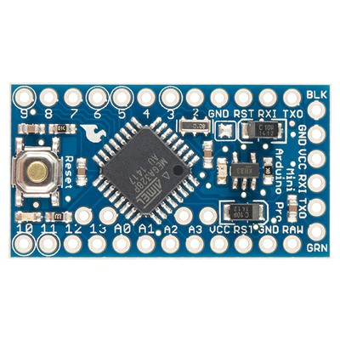

## Sparkfun Bluetooth Mate Gold

Bluetooth modem breakout with single FTDI breakout interface. Easy to hook up with Arduinos.In basic terms, it is a wireless serial emulator, in other words, having two of these connected to two separate microcontrollers can function as if the microcontrollers are wired up via their serial ports.

website: https://www.sparkfun.com/products/12580

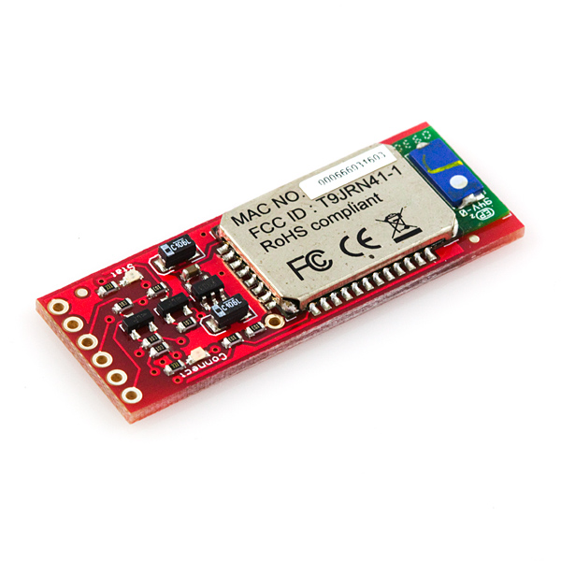

## Sparkfun FTDI Basic Breakout ( 3.3V )

A basic easy to use FTDI breakout. Quite useful when interfacing a computer with microcontrollers or device which do not have internal FTDI convertors.

## BOSCH BNO055

The BNO055 is a System in Package (SiP), integrating a tri-axial 14-bit accelerometer, a tri-axial 16-bit gyroscope with a range of ±2000 degrees per second, a tri-axial geomagnetic sensor and a 32-bit microcontroller running the company’s BSX3.0 FusionLib software. At just 5.2 x 3.8 x 1.1 mm³, it is significantly smaller than comparable discrete or system-on-board solutions.

website: http://www.bosch-sensortec.com/en/bst/products/all_products/bno055

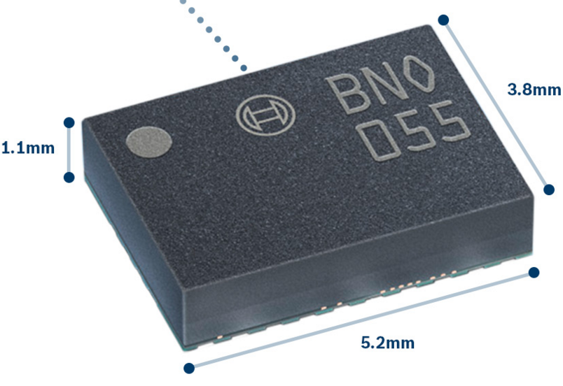

## Adafruit BNO055 Breakout

website: <https://www.adafruit.com/products/2472>

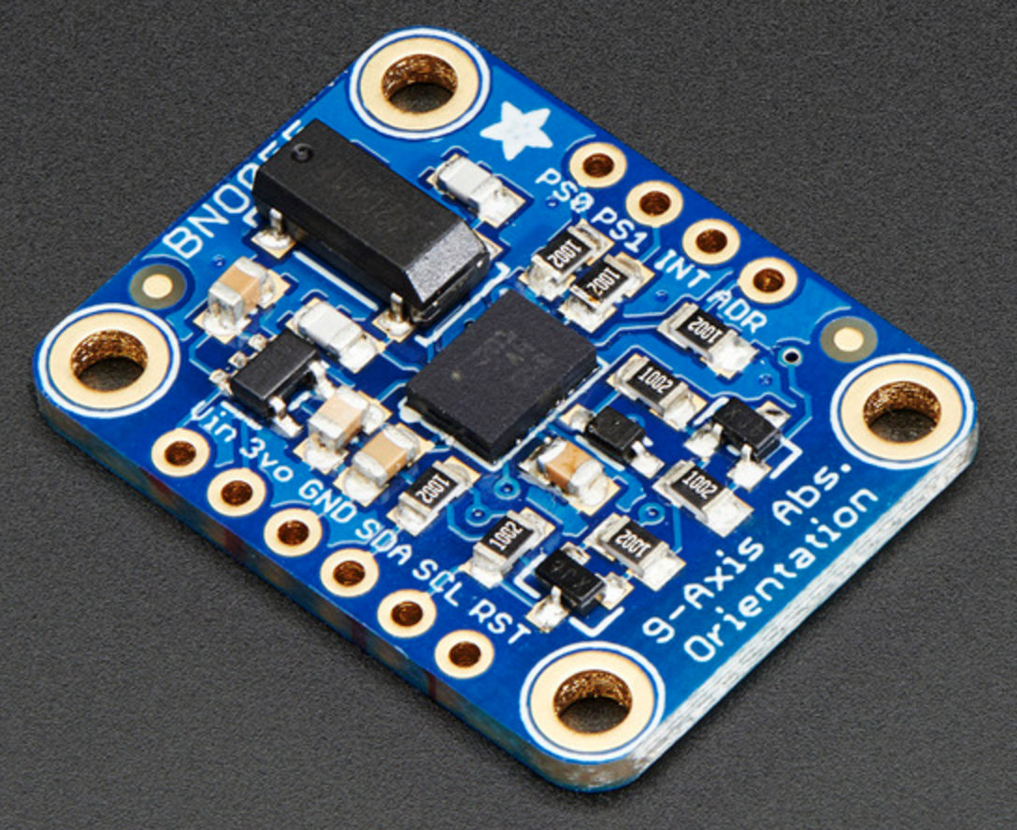

# Diagrams